THE FENESTRA SERIES
2020/2021

The Latin word fenestra refers to a window, but also more widely to an opening, a niche or portal. Penetrating the solidity of a wall, the window is a space of passing through, of shifting images, reflections and shadow. Like the retina it is a screen on which images coalesce. The word fenestra, with its associational richness, surfaces in unexpected places. The term, for example, is adopted in Biology to refer to small holes in bone structure, and to the tiny passage between middle and inner ear, where sound waves pass and are transformed into electrical triggers to become audible meaning. The Hyalurga Fenestra moth of South America has transparent spots on otherwise opaque wings. It appears to mimic its surroundings or become its background.

Like any border or boundary, the fenestra is both a simple physical space, or juncture between spaces, and a set of complex processes of
transformation. It reveals and disguises at the same time, it confuses the object and its surroundings.
The window is a spaceless screen on which invisible forces play, mist and fog, obscure and reveal.
Scientifically, a glass pane is somewhere between a solid and an imperceptibly slow moving liquid. The paintings in the series do not represent actual windows and the Fenestra title serves not as a description but as an entry into the works through analogy. The paintings are more concerned with liquid moving states than tangible, settled ones. The works generate an array of different types of movement and transformation. There are multiple energies in the works; the painterly flows and runs, the vertical spine-like movement beyond the frame, hints of grids migrating in all directions.

Multiple points of focus, often on semi-gridded planes, deny the ability to focus on any one centre, forcing the eye to wander across and beyond the surface. In an analogous dynamic to the surface screen of a window, invisible tensions appear to disturb and transform the painting plane.

The invisible stirs the surface of the visible.

Ron Left 2021

The Fenestra Series No14, 2020 Acrylic on Plywood, 1200mm X 2400mm Triptych

RON LEFT
email: ronleft15@gmail.com website: ronleft.com

ARTIS GALLERY
280 Parnell Road, Auckland +64 9 3031090 artis@artisgallery.co.nz www.ArtisGallery.co.nz
R O N L E F T
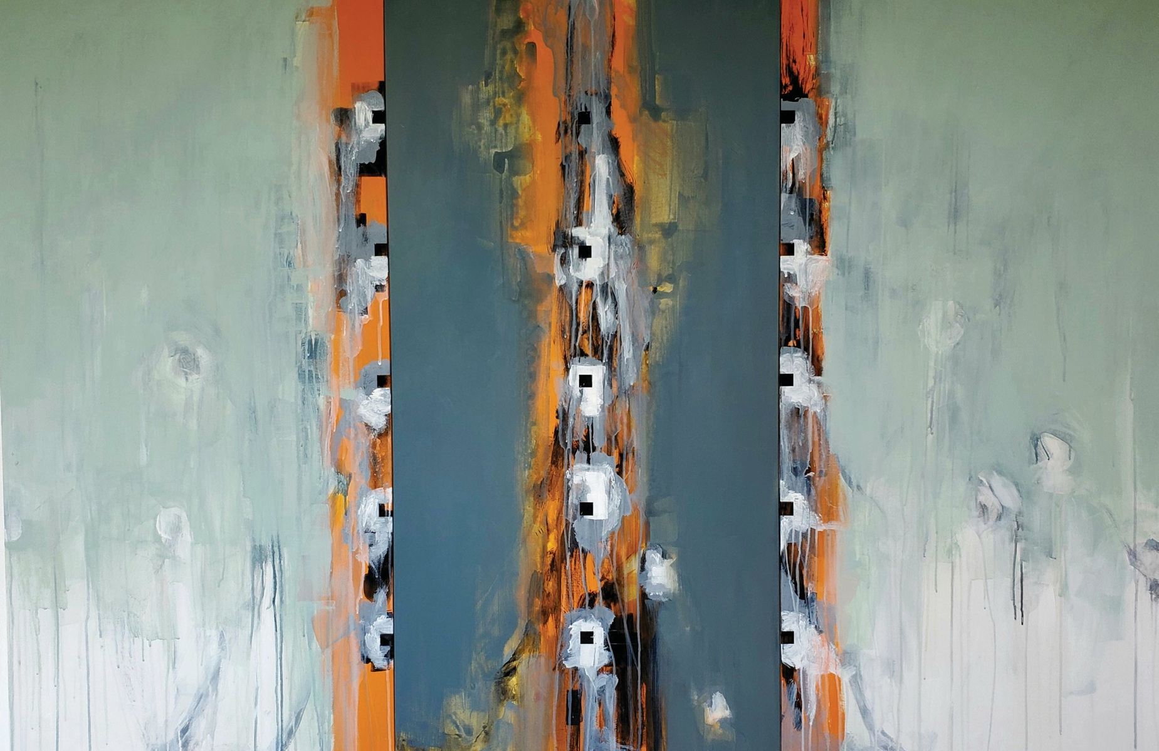
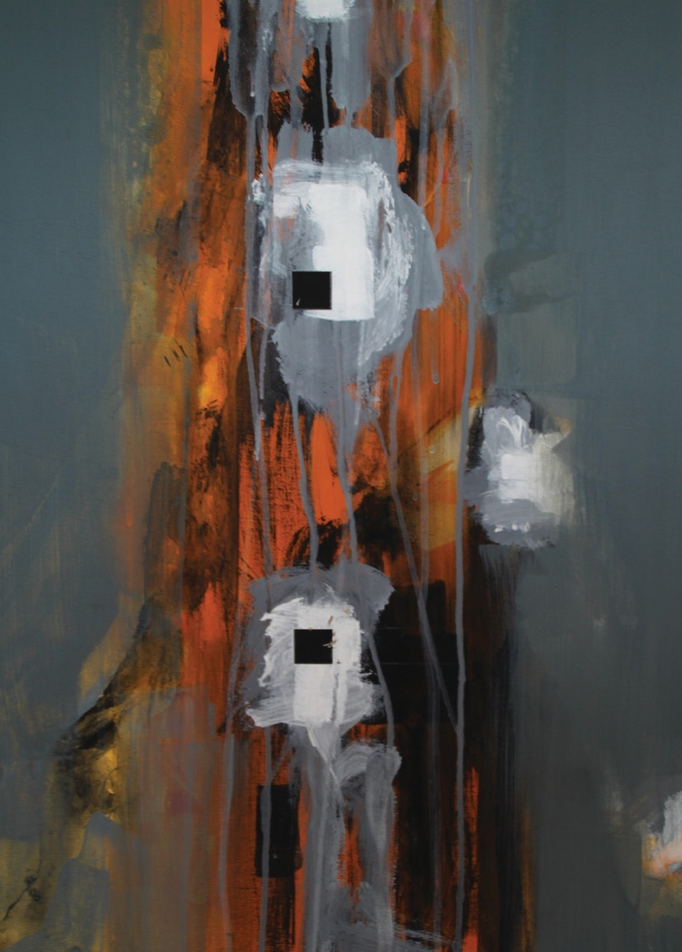
THE FENESTRA SERIES
ARTIS GALLERY
20 April - 9 May 2021

